***Tom Ford Santal Blush***

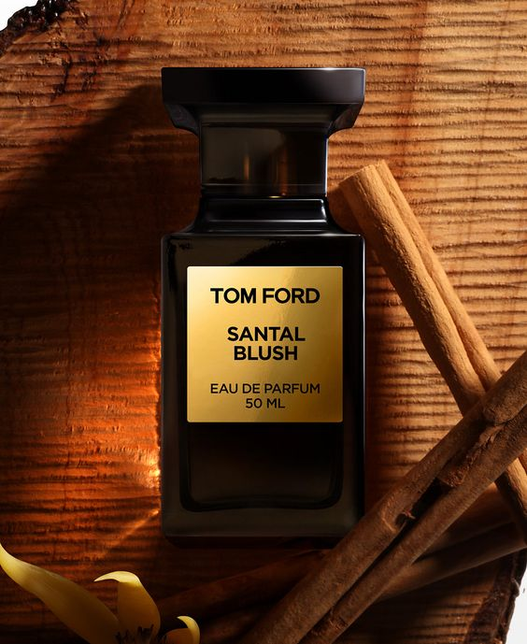

*The top notes of Santal Blush are quite normal and natural: sharp, dry and fragrant with resin with notes of frankincense and fennel. As time passed and the initial sharpness became more quiet, the sweetness of cinnamon and rose began to reveal, followed by the sandalwood note moving slowly and slowly to fill in. filled the cold voids with a little warmth and softness. The end will be a mixture of oud wood and leather with a strong smoky and dry scent, followed by soft, delicate jasmine and ylang-ylang flowers and meanwhile sensual musk is gradually ignited and then all. both explode in an intense and striking way.*